**Longest Bitonic Subsequence**

Problem

Given an array a[] of size n, our task is to find the longest bitonic subsequence

Bitonic: Unlike LIS, it can first increase and then decrease.

Possible bitonic subsequences nature

1. First increases then decreases
2. Only increases
3. Only decreases

Example

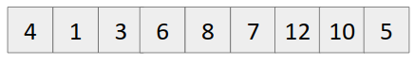

Few subsequences which are valid

{4}, {4,1,3}, {8,7,5}, {1,3,6,8}, {1,3,6,8,12,10,5}, {1,3,6,7,12,10,5}

Maximum Length = 7.

Brute force approach

1. Compute all subsequences
2. Choose the one with maximum length and following the property of bitonic subsequences.

Time Complexity: O(2n)

Optimal Solution (Using dynamic programming)

1. Similar to the longest increasing subsequence question.
2. Make two tables of LIS,
   1. One from starting (LIS1)
   2. Other from end (LIS2)
3. Iterate over both the tables/ arrays and store the maximum of (lis1[i] + lis2[i]-1).
4. Output this maximum value.